Create/Edit Tariff

Module Description

Tariff Screen

You can create and edit a tariff,

Be aware, if you choose a time or date tariff, the time and volume of all devices using the same account will be added. So if you have two devices online at the same time, your usable time is used twice as fast as normal.

Non-Restricted Tariffs
If you want a tariff without any time and volume restrictions, leave the “Runtime” and “Capacity” Field empty.
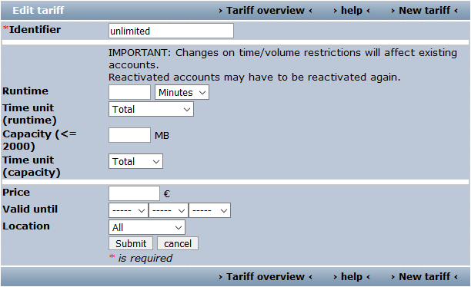

Fields

IMPORTANT: If you change time and/or volume restrictions (runtime, time unit, capacity or time unit (capacity)) this will affect existing accounts and could lead to unwanted effects. Especially if you have accounts, that were reactivated, i.e. you wanted to ignore all usage before reactivation, this information gets lost when you change the tariff and you need to reactivate these accounts again. Just keep in mind that previous rules to restrict hotspot usage will be replaced by the new rules, but all data regarding time and volume consumption are still there.

Field | Description
Identifier | The name of the tariff.
Runtime | The time duration for accessing the internet, Runtime and Time unit (runtime) are dependent on each other.  For example,  If runtime is “40 minutes” and time unit is “Daily”, then the hotspot users are allowed to use the internet 40 minutes per day or If runtime is “40 days” and time unit is “from the first login”, then the hotspot users are allowed to use the internet 40 days after the first login and so on.  Runtime and time unit depend on capacity, for example, If runtime is “50 minutes”, time unit of runtime is “Total”, capacity is “40MB” and time unit of capacity is “Total”. The hostpot users could be limited by capacity, because 40MB could be finished before 50 minutes.
Time unit (runtime) | Please see the description of Runtime.
Capacity (⇐ 2000) | You can limit the capacity for use. Capacity and Time unit (capacity) are dependent on each other.  For example, if capacity is 400MB and time unit of capacity is Daily, then the hotspot users can only use 400MB per day.
Time unit (capacity) | Please see the description of Capacity.
Price | Total price for the tariff.
Valid until | The tariff won't be shown after this date.
Location | Tariff is chosen for all or different locations.

