Migration to new URL

Background
As you may have noticed, the company Bintec Elmeg GmbH has gone bankrupt and has therefore stopped working on our common hot spot solution.
Disabling the URL bintec-elmeg.com will prevent the accessibility of the website as well as the functionality of the installed routers! Therefore we linked a new URL https://hotspot.syces.de to the webserver, providing access to the same database.
To ensure future functionality of the configured routers, this new URL must be configured on the devices. This page provides detailed instructions on how to do so.
For more information and customer support, visit the website Concat AG.

Prerequisites
In order to change a configured router to the new URL, you need administrative access to said router. In the following the configuration is shown using the web interface of a Bintec router.
Additionally, you need to know the network configuration of your setup to gain access to the router through a preconfigured interface. Depending on your setup, you may need to address the router via a different IP address.

Step 1
Call the router's web interface by entering the IP of the router in a browser of your choice on a device connected to the router. Depending on your router's configuration it might be easiest to plug in your device in a subnetwork of the router.

Step 2
Log into the router's web interface using your credentials.
Hint: The default name of the user is admin. Next navigate to the menu Local Services > HotSpot Gateway.

Step 3
Open the active hotspot gateway entry. Replace the domain “bintec-elmeg.com” by “syces.de” in every occurrence.
The following image displays an example configuration before the migration:
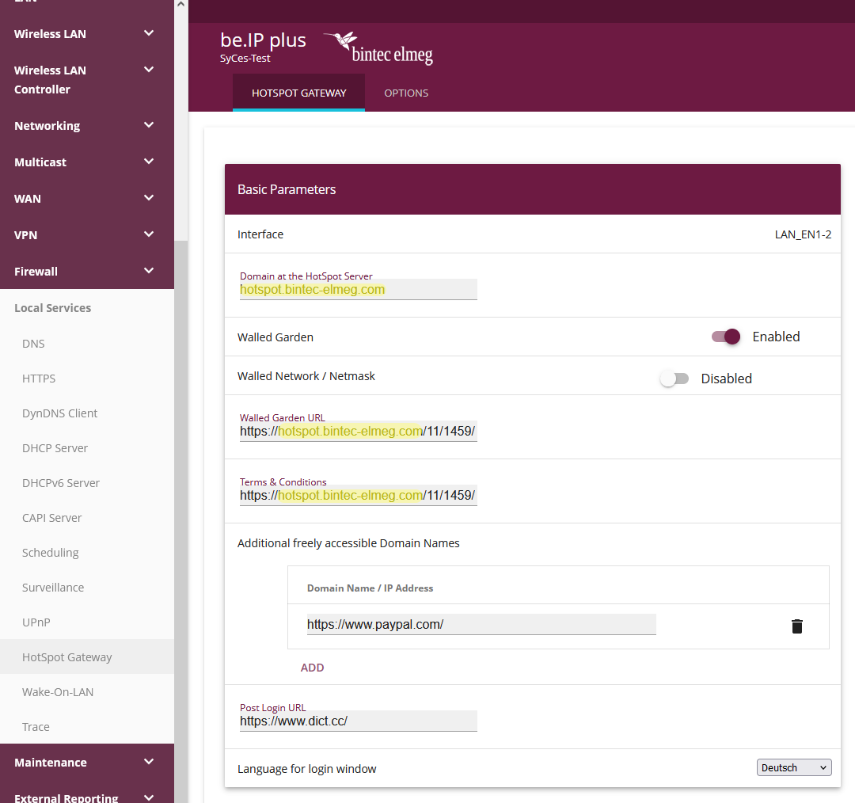
The next image shows the same router with the new URL configured:
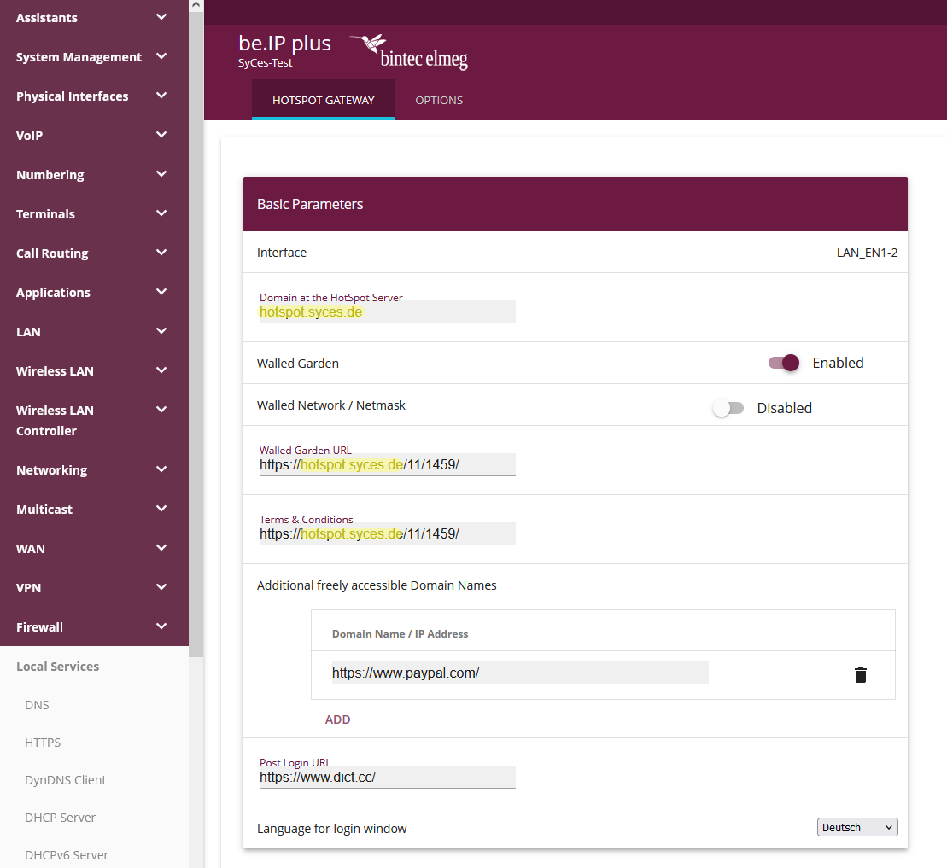
Please note that the client and location ID (numbers in the URL) of configured locations did not change and therefore need to be kept the same.
Since the remote authentication still works on the same web server, there is no need to adapt the RADIUS IP or secret!

Step 4
Congratulations. You have successfully changed the router to call the new URL.
Please test, if a device logging into your network is redirected to the new URL like “https://hotspot.syces.de/11/1459/” and test the login.
If your testing was successful, please log out of the router using the exit and save configuration function in the top right corner.

Troubleshooting
If you have problems migrating your router or if any unexpected behavior appears, please contact us via hotspot@concat.de.

